
The Washington Informer
Black News, Commentary and Culture | The Washington Informer
Posted inPolitics
House Minority Leader Jeffries Zeros In With Speakership on the Horizon

by Ashleigh Fields
September 9, 2026
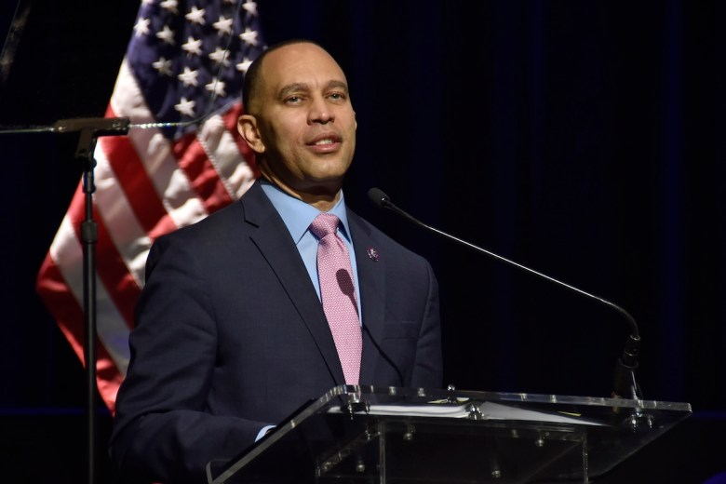**FILE** With November’s midterm elections ahead, if Democrats are successful, House Minority Leader Hakeem Jeffries will likely ascend to the speakership, becoming the first Black man to hold the office. (Robert R. Roberts/The Washington Informer)
Balance. Poise. Purpose. These three components are staples for any career in politics and any hope for a shot at leadership in Congress.

House Speaker Mike Johnson (R-La.) has managed to maintain a House divided as GOP lawmakers grapple with a demanding president.

He’s also palmed legislative wins for the Republican Party amid discourse in the Senate throughout two speakerships and the threat of dismissal from his colleagues.
It’s a looming fate that haunts every member of the House who dares to jump into leading an entire class of lawmakers through historical ups and downs.
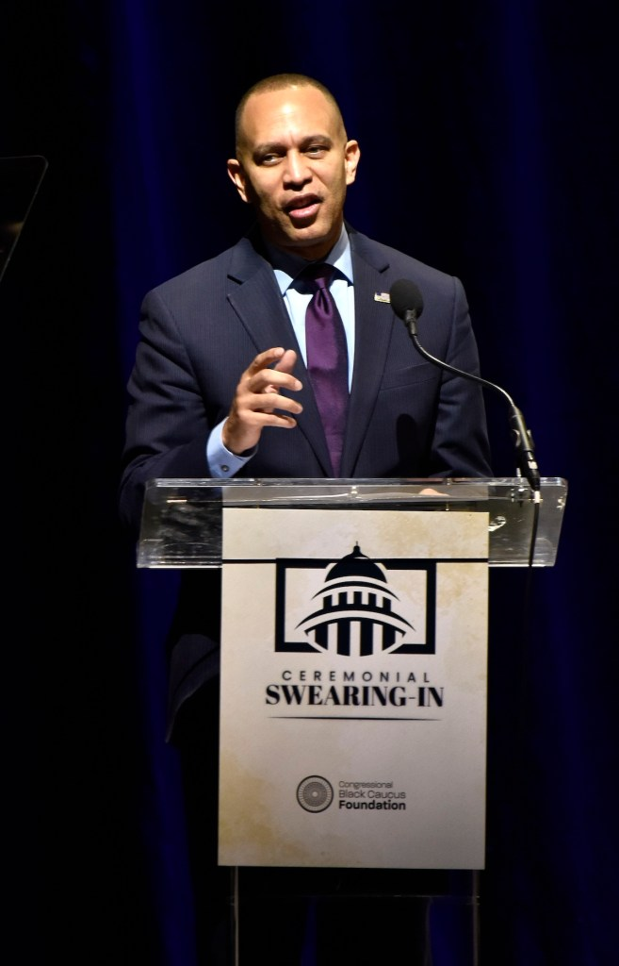
If he becomes House Speaker, House Minority Speaker Hakeem Jeffries says he will focus on several challenges facing Americans, including affordability, Supreme Court reform and voting rights. (Robert R. Roberts/The Washington Informer)
Midterm elections can offer yet another threat of a fatal blow to those in power.
Republicans are on the chopping block and fighting to keep hold of the majority in the lower chamber while Democrats are hoping to score a series of House victories in November.

If successful, House Minority Leader Hakeem Jeffries (D-N.Y.) could potentially ascend to the speakership, becoming the first Black man to hold the office and wield the quintessential gavel.

“This is historic and groundbreaking, not only because he could break barriers as the first Black Speaker of the House, but because of the night and day difference in what the House will now accomplish contrasted to under Mike Johnson’s leadership,” former White House communications director Robert Weiner told The Informer.

A House Speaker decides which bills reach the floor for debate, appoints members to select and conference committees and remains second in line of succession for President Donald J. Trump.

“We can cut his presidency legislatively in half by winning the midterm elections, and that’s incredibly important,” Jeffries said.

Here are five areas the House Minority Leader said he would concentrate on as Speaker:

Affordability

Jeffries said cutting costs is a clear priority for the Democratic party citing tariffs and cuts to health care coverage as reasons for the rise in prices.
“I think most importantly, everybody is focused on the notion that life is too expensive in the United States of America,” Jeffries told reporters in Atlanta at the annual National Association of Black Journalists (NABJ) conference. “This is the case in our community, in the Black community, for those who are working hard, they’re playing by the rules, but they can’t thrive and they can barely survive.”

Inflation has not fully cooled from the COVID-19 pandemic.

Grocery costs increased by 25.1 percent while shelter and utilities costs increased 33.9 percent, and car insurance costs increased 41.2 percent between 2019 and 2025, according to the Common Sense Institute, a nonpartisan think tank.

“That’s got to change,” he declared.

Accountability

Jeffries said he would help the economic crisis in some way by holding Trump and others in power accountable for earning profit off of their status as an elected official.
However, he doubted that he’d have support from Republicans.

“I don’t know that we’ll get partnership on corruption, with the few common sense Republicans that are left in Washington,” he added, “but we can hold people accountable by ourselves in the majority through gavels and subpoena power.”
Lawmakers from the majority party serve as committee chairs with authority over investigations and legally binding subpoenas to request testimony from individuals related to their probe.

This year, Republican lawmakers called former President Bill Clinton and his wife Hillary to testify before a committee in regard to deceased sex offender Jeffrey Epstein.
Jeffries says he plans to continue investigating the full log of the Epstein files in the majority alongside deep dives on government corruption.

“He promised to release the Epstein files, broke that promise. We forced a vote on the issue. About half the files have been released,” Jeffries said. “The other half is still being subjected to a cover-up by the Department of Justice.”

Supreme Court Reform

Earlier this year, the Supreme Court expanded presidential authority in a case brought against Trump, further inflating debates on the restraints of the executive office.
House Minority Leader Jeffries said the high court’s ruling extending presidential power over independent agency heads “eroded democracy” and argued that Democrats would push for “dramatic reform.”

“You have a series of systematic decisions going on the last 15 plus years that have really decimated our democratic fabric. And we’ve got to unravel all of it,” Jeffries said.
In April, the high court moved to restructure the Voting Rights Act to make it harder to create majority Black districts to prevent the systematic dilution of African American voting power.

He noted that efforts to redraw congressional maps outside of their cycle was effectively the Supreme Court aiding and abetting “MAGA extremists” and “unleashing Jim Crow-like tactics in the South.”

Voting Rights

The Democratic leader said the party will focus on passing the John Lewis Voting Rights Act if elected to the majority in the fall.
The legislation would ensure a 180-day notice ahead of changes to voter precincts and implement measures for oversight for states and local governments with a recent history of voting discrimination.

Jeffries said the “initial attack” on the Voting Rights Act happened when the Supreme Court chose to “decimate” Section 5 of the Voting Rights Act, which requires specific jurisdictions with a history of racial discrimination to get federal approval before changing any voting laws.

In 2013, the Supreme Court rendered Section 5 effectively inactive by declaring that the formula used to determine which states and local governments had a history of discrimination and needed federal approval called “preclearance” before changing their voting laws was unconstitutional.

“Then a few years after that you had the Supreme Court declare that partisan gerrymandering is all, you know, fair in the political sphere and that there’s nothing to prohibit it in the Constitution,” Jeffries said.

He noted that a recent Supreme Court ruling weakening Section 2 of the Voting rights and a separate ruling expanding Trump’s immunity as the president were the “final devastating” blows to democracy.

“So you have a series of systematic decisions going on the last 15 plus years that have really decimated sort of our democratic fabric. And we’ve got to unravel all of it,” the House Minority Leader said.

Jeffries noted that the John Lewis Voting Rights passed two times in the House under Democratic leadership with support from Rep. Terri Sewell (D-Ala.), but failed in the Senate.

He blamed the loss on the filibuster.

“I think we’ve talked about as House Democrats, is look, we have to continue to stretch.
We’re in a ‘more is more’ environment. And because of the unprecedented extremism being unleashed on the American people, we have to be in a position to do more, and do more differently, and do more creatively,” Jeffries said.
“And that’s what we’ve tried to do.”

Filibuster Reform

In simple terms, the filibuster is a procedural rule followed in the Senate when someone is attempting to delay or block a bill.

A senator or senators can speak for an unlimited amount of debate for an unlimited period of time delaying a vote on a matter.

In order to end the debate, lawmakers must introduce cloture, which would mean securing 60 out of 100 votes in favor of passing a law. No one party can achieve the magic number alone.

The procedure ensures there is balance and agreement between both the Democratic and Republican parties, rather than allowing a bill to pass with the simple majority of 51.

Some lawmakers, including Jeffries and former President Barack Obama have said the procedural rule is a “relic” of the past.

Others say it protects the minority regardless of party.

While on stage in Atlanta, Jeffries quoted former President James Madison as saying the House should be in “intimate sympathy” with the American people.

However, he noted that “in order for that to happen, I think transition, change, renewal will continue to be an important part of the story.”

Democratic strategists say it’s now time for that change, arguing it could “probably” take place with Jeffries as House speaker.

“Helping people with health care, housing, education, equal rights, jobs, and no endless purposeless wars are just the beginning,” Weiner added, “let alone not taking money from those programs by tariffs, war, and tax breaks for billionaires.”

