
Commentary
‘America first’ means saying no to Saudi nuclear power | Opinion
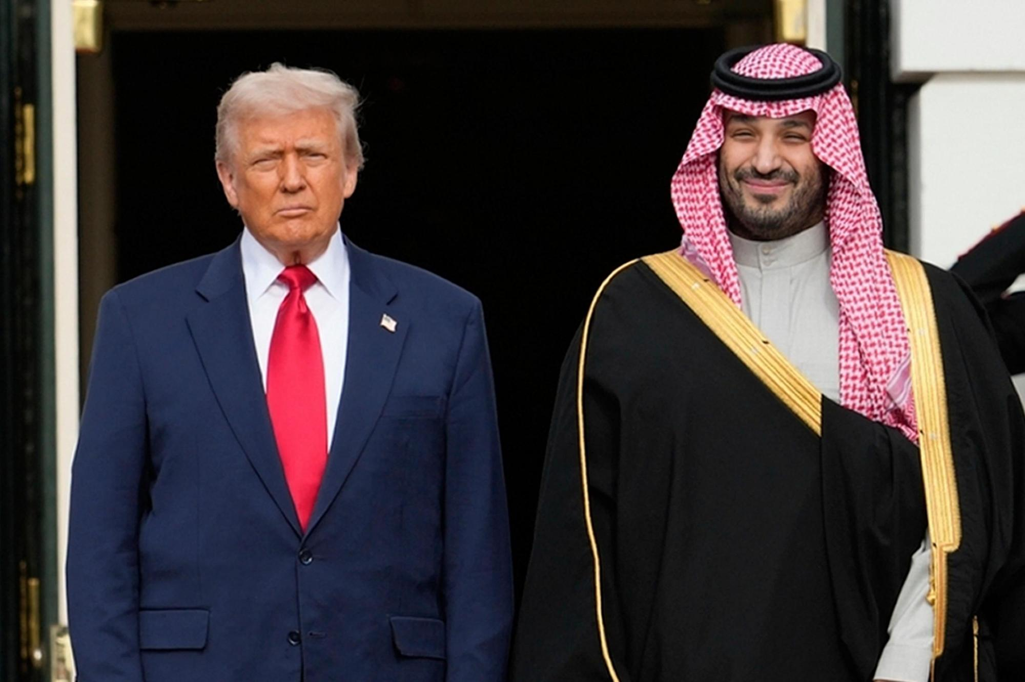
FILE – President Donald Trump stands with Saudi Arabia’s Crown Prince Mohammed bin Salman on his visit to the White House, Nov. 18, 2025, in Washington. (AP Photo/Mark Schiefelbein, File)
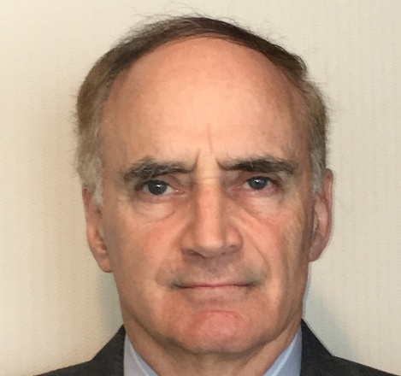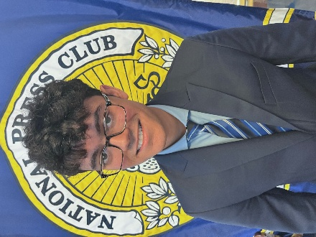
By Robert Weiner and Khel Gordhan
PUBLISHED: August 17, 2026 at 9:57 AM EDT
Just a day after the U.S. agreement to share nuclear technology with Saudi Arabia in exchange for freeing more oil for export went public, President Donald Trump decided to back out of it. In a post to Truth Social, the president demanded the Saudi government join the Abraham Accords and recognize Israel as an extra condition of the agreement.
However, given America’s large oil production, the training of 15 of the 9/11 hijackers in Saudi Arabia, and the CIA information on top-level Saudi involvement in killing reporter Jamal Khashoggi, it is surprising this deal was on the table in the first place. The Saudi nuclear agreement was a bad idea from the start.
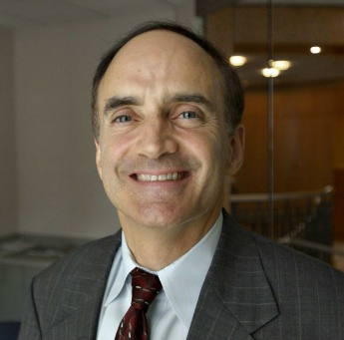
Former Clinton and Bush White House spokesman Robert Weiner.
The United States already produces more crude oil than any other country on earth, at a record-high 13.6 million barrels a day. Of that oil, three-quarters of the refined gasoline delivered to Fort Lauderdale’s Port Everglades comes from refineries in Louisiana, Texas and Mississippi along the U.S. Gulf Coast, according to the county’s Port Everglades Department. In turn, the port supplies roughly one-third of Florida’s gasoline and other refined petroleum products. Domestic oil production is stronger than it has ever been. Why go to the Saudis for something we already have?
Saudi Arabia’s poor human rights track record should also have been a factor against the Saudi nuclear deal. Despite the murder of Khashoggi and involvement in training hijackers, the response from U.S. officials has been timid at best and silent at worst.
Families impacted by 9/11 have expressed their outrage at the Saudi nuclear agreement. Terry Strada, National Chair of 9/11 Families, wrote in her op-ed for RealClearWorld of the necessity to hold the Saudi government to account for their role in one of America’s greatest tragedies: “Before we talk about defense pacts or nuclear technology, let’s first talk about justice.”
To this end, there is an ongoing civil lawsuit from 9/11 families formally accusing Saudi Arabia of providing support to al Qaeda. However, as Strada notes, Saudi Arabia has tried to do everything in its power to avoid accountability by filing motions to dismiss and spending millions on lobbyists and PR firms to pressure the U.S. government to ignore the situation. A nuclear deal with the Saudi government gives the Kingdom tacit permission to avoid answering for its involvement. The United States must stand with the families of 9/11 victims and find alternatives to Saudi oil.
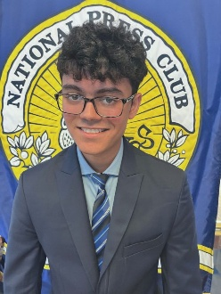
Khel Gordhan is senior editor and policy analyst at
Robert Weiner Associates and Solutions for Change. (courtesy, Khel Gordhan)

One potential avenue to break further from oil dependence from Saudi Arabia is to invest in clean energy. Windmills, solar panels and nuclear power do not require the same deference to a tyrannical kingdom as oil does. Solar, in particular, would be an effective solution in the Sunshine State to meet growing energy needs. There is also significantly less vulnerability to sudden geopolitical crisis. A country could block a global trade route for oil, but nobody can block a country’s access to the sun.
Though Trump has killed his nuclear agreement with Saudi Arabia for now, he often resurrects bad ideas, like his slush fund for Jan. 6 insurrectionists and revoking constitutionally protected birthright citizenship. We already produce all the oil we would need and more, coupled with alternative ways to address energy needs like solar power.
If the Trump administration is serious about putting “America first,” his administration should put the victims of 9/11 first and steer clear of sharing nuclear technology with the Saudi government. Most presidents in recent history have given political favor to the Saudis. But future American policy, regardless of who is president, should instead maintain some distance.
Robert Weiner was chief of staff for Rep. Claude Pepper’s House Aging Committee, communications director of the House Government Operations Committee and a spokesman in the Clinton and George W. Bush administrations. Khel Gordhan is senior editor and policy analyst at Robert Weiner Associates and Solutions for Change.

