

This not the right way to interdict the drugs that are killing Americans
ROBERT WEINER AND HALLVARD MISJE
• December 4, 2025
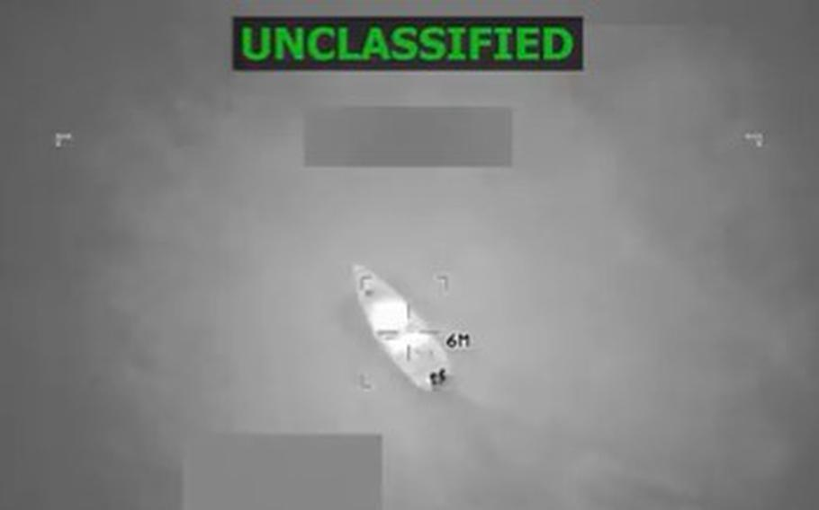
A screengrab of a video posted by Defense Secretary Pete Hegseth on Friday, Oct. 24, 2025, that the U.S. military conducted its 10th strike on a vessel suspected of carrying drugs overnight, killing six people. (Secretary of Defense Pete Hegseth post on X)
Robert S. Weiner is former spokesman for White House Drug Policy Office and U.S. House Narcotics Committee, participant in several government anti-drug missions to Latin America, and senior staff for Gen. Barry McCaffrey, Reps. Claude Pepper, Ed Koch, John Conyers and Charles Rangel, and Sen. Ted Kennedy.
Hallvard Misje is a Norwegian journalist, policy analyst at Robert Weiner Associates News, and was a border guard in the Norwegian army serving on the Russia-Norway border.
To bomb-to-kill the people on Venezuelan boats and threaten a land war appears to be an excuse to weaken and remove Venezuelan President Nicolas Maduro, whom the Trump administration dislikes. It has little to do with the drug issue, since Venezuela is a minuscule piece of the drugs issue. The major suppliers of cocaine to the U.S. are Colombia, Bolivia, Peru and Mexico.
The major supplier of fentanyl and methamphetamine and their chemicals is China (and via Myanmar), and includes transportation through Mexico. When you consider that President Donald Trump just pardoned from a 45-year prison term the ex-president of Honduras who said he wanted to “shove the cocaine up the noses of the Gringos” and was convicted of a conspiracy supplying 400 tons of cocaine to the U.S., the administration comes across as not really caring about the drugs, just about getting Maduro out. Great Britain, a major U.S. cooperator against international financial crimes, and Colombia, a key (and the largest) partner in combating narcotics, now have both halted intelligence sharing in the Caribbean with America because of the apparent illegality and extreme nature of the U.S. military strikes. Barry McCaffrey, a retired U.S. Army general, was the commander of U.S. Southern Command and later was the White House National Drug Policy director who conducted several anti-drug missions to Latin America and Mexico on which we participated. His plan supporting Colombia’s aerial eradication and alternative crop substitution dropped cocaine production by half and reduced crack supplies in the U.S. by two-thirds.
On Dec. 3 he said that aerial eradication has been stopped in Colombia and as a result, in the last 10 years, cocaine production has tripled. His missions to Colombia helped teach the military there how to be effective in curtailing drug supplies and avoiding human rights violations — which means not killing survivors hanging onto bombed boats at sea.
There is a right way and a wrong way including the military to conduct counternarcotics and drug interdiction. The current administration needs to learn those and stop playing politics against leaders they oppose at the expense of the real drug killing of Americans — over 100,000 of whom die a year — from drug overdoses.
Read more at:
https://www.stripes.com/opinion/2025-12-04/wrong-way-to-interdict-drugs-caribbean-19981296.html
Source - Stars and Stripes

